# Judicial Advanced Mechanics and Amazing Artificial Living

## Overview

**Overall Tone:** The tone will be a blend of Waititi's quirky humor, Peele's social commentary and suspense, and the gritty realism of "The Walking Dead." This means serious character development interwoven in a funny and horrifying world.

## Characters

* **Rick's Group:** Rick, Daryl, Michonne, Carol, Glenn, Maggie, etc. (As of the prison arc).
* **Team:**

|  |  |
| --- | --- |
|  | **John (The Sheriff):** John is the leader, trying to do the right thing while navigating the complex politics of the undead world. |
|  | **Jamaal:** Still the "adventurous capitalist," but now he sees the zombie apocalypse as a market opportunity. He's always looking for ways to profit, but he also wants to be accepted by the group. |
|  | **Dave:** His "Orthogonal Random Beamforming" brain comes in handy for strategizing against zombies, but he's still socially awkward and paranoid. He's constantly muttering about "data breaches" and zombie weaknesses. |
|  | **Mac:** Still feisty and protective, but she's found a renewed sense of purpose in fighting zombies. She has an intense loyalty to the group and a deep distrust of outsiders. |
|  | **Ed "The Hashbrown" H.:** A surprisingly effective zombie killer, but his seafood allergy makes scavenging for supplies difficult. He’s got a dark sense of humor that comes out in tense moments. |
|  | **Ian (Necromancer):** Quiet and unassuming, but he possesses a strange ability to communicate with (or at least influence) the dead. He's trying to figure out the extent of his powers and how to use them for good. |
|  | **Jason:** A tall, semi-professional Latin dancer who works for a company that leases printers. |
|  | **Rob C. (The Departed):** Recently departed, enjoyed weekend fishing, a source of tension between the Sheriff and Jamaal |
|  | **Jean appears as a God:** Jean is on high in the sky. |
|  | **Justin:** Not in the story yet |
|  | **Stewart:** Not in the story yet |
|  | **“The Ice Cream Truck”: reoccurring background character, mostly broken down (side of the truck reads J.A.M.A.A.L Ice Cream)** |

## Additional Details

* **Taika Waititi Quirky Humor:** Expect plenty of offbeat humor throughout the arc, including running gags about Ed's seafood allergy, Dave's paranoia, and Jamaal's attempts to monetize the apocalypse.
* **Jordan Peele Social Commentary:** Expect subtle but powerful commentary on themes of race, class, and social injustice. The Walkers can also be interpreted as a metaphor for societal ills, such as greed, selfishness, and apathy.
* **Necromancy as a Metaphor:** Ian's necromantic abilities can be seen as a metaphor for understanding and connecting with the past. It's also a commentary on the dangers of unchecked power.
* **"Lattice-Core Beam" as a Metaphor** By the end, all teams have become like "Lattice-Core Beam"
* **Jean appears as a God:** Jean is on high in the sky.

This "Walking Dead" arc would be a wild and entertaining ride that blends Waititi's humor, Peele's social commentary, and the gritty realism of the zombie apocalypse. It would also be a powerful exploration of teamwork, trust, and the importance of community in the face of adversity and a bizarre method to have John's company improve its interpersonal capabilities.

## Episode 1: "Welcome to the Dungeon" Overview

* **Written by:** Taika Waititi
* **Directed by:** Jordan Peele
* **Opening Scene:** A classic Peele-style cold open. John and his team are scavenging for supplies in an abandoned office building. The scene is played for laughs as Jamaal tries to haggle with a decaying corpse for a bottle of hand sanitizer, but the tension quickly ratchets up as walkers swarm the building.
* **Plot:** John's team stumbles upon the prison, cautiously approaching with weapons drawn. Rick's group is wary but lets them in after a tense standoff. There's immediate friction between Rick's group and John's team, fueled by mistrust and differing philosophies.
  + **Dave's Paranoia:** Dave is convinced that Rick's group is hiding something and is constantly trying to "decode" their behavior using his unique analytical skills.
  + **Mac's Distrust:** Mac is immediately suspicious of Rick, seeing him as an overbearing leader. She clashes with Carol, who Mac sees as "too soft."
  + **Ed's Dark Humor:** Ed makes inappropriate jokes about the prison's former inmates, much to the disgust of Maggie and Glenn.
  + **Jean as the Silent Observer:** Jean is just an outside entity at this point, but maybe she makes a couple of appearances in the sky.
* **Ian's Introduction:** Ian is initially terrified of the walkers but discovers he has a strange connection to them. He tries to communicate with the dead, but his attempts are clumsy and ineffective. He speaks through a "Ouija brand" boardgame.
* **Conflict:** A walker outbreak inside the prison forces the two groups to work together, highlighting their strengths and weaknesses. There is a debate on what to do with walkers, and whether they should even be put down with Dave lobbying that the human race should try to understand them, which could lead to a better understanding of where the human race is heading.
* **Ending Scene:** A cliffhanger ending as the Governor's men are seen approaching the prison from a distance. The last shot is of Ian touching one of the walkers and his eyes turning blue, ending the episode with the potential for the power of necromancy to be real.

## Episode 2: "Prison Break (Down)" Overview

* **Written by:** Jordan Peele & Taika Waititi
* **Directed by:** Jordan Peele
* **Opening Scene:** The Governor's arrival outside the prison is intercut with flashbacks to Rob C.'s sudden retirement. The flashbacks hint at a conspiracy within the company, and Jean's silence takes on a more sinister tone.
* **Plot:**
  + **The "Durchfallen" Mirror:** The conflict between Rick and the Governor becomes a mirror for the conflict between John and Jamaal. Jamaal sees the Governor as a savvy businessman, willing to do anything to protect his interests, while John view him as a ruthless tyrant.
  + **Dave's Strategic Genius:** Dave uses his analytical skills to devise a plan to defend the prison, but his paranoia leads him to suggest extreme measures that Rick rejects. The rejection frustrates him, because the long term data supports his conclusions. He suggests that Rick's team and John's team will be able to save the most amount of people through his plan.
  + **Ian's Powers Grow:** Ian begins to experiment with his ability to control the dead, but his powers are unstable and unpredictable. He accidentally unleashes a horde of walkers on the prison, forcing the two groups to fight together.
  + **Internal Conflict:** As the threat from the Governor grows, the internal conflicts within the group intensify. Mac starts to question Rick's leadership and considers siding with the Governor, seeing him as a strong leader who can protect the group. Ed starts making tasteless jokes.
* **Social Commentary:** The episode explores themes of leadership, power, and the cost of survival. Jordan Peele also integrates subtle commentary on the exploitation of workers, relating to the themes of "Sorry to Bother You".
* **Ending Scene:** The Governor launches a full-scale assault on the prison, and the episode ends with Rick's group and John's team scattered and on the run. Ian's necromantic powers seem to have been activated, but what exactly he has done is to be determined.

## Episode 3: "Lattice-Core Hope" Overview

* **Written by:** Taika Waititi
* **Directed by:** Jordan Peele
* **Opening Scene:** A montage of the team scattered and fighting for survival in the woods. Ed "The Hashbrown" H. somehow loses all his fishing gear.
* **Plot:**
  + **Reconciliation and Unity:** Faced with a common enemy and the loss of their home, the two groups start to put aside their differences. John and Jamaal have a heart-to-heart, realizing that they need to work together to survive.
  + **Dave's Data-Driven Empathy:** Dave, using his "Orthogonal Random Beamforming" brain, analyzes the team dynamics and realizes that unity is the only way to survive. He uses his unique communication skills to bridge the gaps between the two groups.
  + **Mac Finds a Cause:** Mac finds a renewed sense of purpose in protecting the younger members of Rick's group, realizing that she can use her strength to help others.
  + **Ian's Full Potential:** Ian finally masters his necromantic abilities and uses them to turn the tide against the Governor's forces. He raises an army of walkers, but he also shows that he can control them and use them for good. It turns out he has an innate ability to reason with the dead, a great weapon.
* **Climax:** The two groups confront the Governor in a final showdown. The battle is brutal and chaotic, but they are able to defeat him with the combined strength of their skills and the power of Ian's zombie army.
* **Resolution:** The episode ends with the two groups deciding to band together and find a new home. They've learned valuable lessons about trust, cooperation, and the importance of community.

# Episode 1: “Welcome to the Dungeon (With Bioinspired Snacks)”

*Written by:* Taika Waititi  
*Directed by:* Jordan Peele

*Characters:* (All As Previously Defined)

*Opening Scene:*

The scene opens with John and hiss team scavenging for supplies in a deserted office building. The fluorescent lights flicker erratically, casting long, distorted shadows. The air is thick with the stench of decay.

*The corpse (propped against a desk) slowly turns its head and starts approaching*

As Jamaal gets surrounded the screen cuts to a flashback to the office breakroom before the apocalypse. Rob C. is microwaving fish, the smell is rancid.

*Mac chimes in "yeah it is, at least that's just fish!"*

Transition to the Prison:

* As the horde closes in, John's team makes a daring escape through a narrow service tunnel, emerging into a dense forest. Exhausted and low on supplies, they stumble upon a high chain-link fence topped with razor wire – the prison.
* *John:* “That’s… that’s something. Looks secure, at least.”
* *Dave:* (Scanning the perimeter with binoculars) “High-security protocols… multiple layers of fencing… potential blind spots at the north gate… I’m picking up conflicting signals… this could be a trap!”  
  Meeting Rick’s Group:
* John's team cautiously approaches the prison gates, weapons drawn. Rick’s group, hardened and wary, watches from the guard towers.
* *Rick:* (From the tower) “Hold it right there! State your business!”
* *John:* “We’re survivors. Looking for shelter. We come in peace.”
* *Daryl:* (Scoffs from the tower) “Peace? Ain’t seen much of that lately.”
* After a tense standoff and a careful vetting process (including Dave’s failed attempts to “decode” their intentions), Rick reluctantly agrees to let John's team inside.  
  Inside the Prison – Immediate Friction:
* The prison’s grim atmosphere and the stark contrast between John's team’s quirky camaraderie and Rick’s group’s battle-hardened stoicism creates immediate tension.  
  Justin’s Insight:
* While exploring the prison, Justin discovers a dusty archive containing old research reports.
* *Justin:* (Excitedly) “Check this out! Rob C., was experimenting with self-healing concrete! It could be a game-changer for reinforcing these walls!” Justin pulls a sheet out and notes that it is something he was planning to have.
* *John:* “The “the power of nature to enhance materials designed for the harshest environments”?”  
  Dave’s Paranoia:
* *Dave:* (Whispering to John) “I’m detecting inconsistencies in their stories… discrepancies in their behavior patterns… the power grid is drawing an unusual amount of energy… I think they’re hiding something… something big…” Dave continues his analysis, muttering about potential betrayals.  
  Mac vs. Carol:
* Mac observes Carol as she gently tends to a wound on Carl, Rick’s son.
* *Mac:* (Scoffs to John) “She seems nice, but how long do you think that’ll last around here? She’s too soft for this world” *Mac is cleaning her shotgun*
* *John:* She has been though a lot. Give her a break.  
  *Carol does a cool thing and then Mac responds* “Maybe there is something there, but I still don’t trust her.”  
  Integration:  
  *Justin & Jamaal:* The two connect over the bioinspired materials from the lab.
  + *Justin explains that because of the army, he is able to take the concepts and use it better.*
  + *Jamaal explains that with Justin’s knowledge and his knowledge of bio engineering this could be something that could make a difference in the long run*  
    Mac’s Dog & A Moment of Connection  
    *Mac:* “I have not talked about my dog in awhile. What about you Jamille (Jamaal), what pets did you own?”  
    *John:* “I have never had any, but it sounds like the dogs make you happy.”  
    *Mac:* “Yeah, they did and that is all that matters.”  
    Ian Finds a Guide:
* In all chaos, it is not that the zombies are bad and want to kill, they are just hungry. He believes that he can reach the zombies with the right tools.  
  Ed vs. Daryl:
* As the group settles into the prison, Ed, trying to ease the tension, makes an off-color joke about the former inmates.
* *Ed:* “I wonder if they had fish here too! Ha! It’s a shame all this food went to waste”
* Daryl’s eye twitches.
* *Daryl:* “Watch your mouth, Hashbrown.
* *John:* (Intervening) “Ed, maybe tone it down a bit.”
* *Ed:* “It’s just a joke! Relax.  
  Justin’s New Role:
* *John:* “Justin, take charge of it.”  
  *Justin smiles and states,* “It is a pleasure to be of service.”  
  Ian’s Introduction:
* *Ian:* (Whispering, almost to himself) “…they’re not gone… they’re just… different.”
* *Glenn:* (Approaching Ian cautiously) “Hey, you okay, man? You look a little freaked out.”
* *Maggie:* (Nodding in agreement.) “Yeah, you do man. What’s going on?”
* *Ian:* “What are your names? Do you have friends who have passed?” (Looks back at them with a tear in his eye). “Do you want to maybe speak with them?”  
  Conflict:
* A sudden alarm blares throughout the prison, signaling a massive walker breach. The two groups are forced to fight side-by-side, highlighting their different combat styles and philosophies.
* *Rick:* “You don’t need to know how we do things…”
* *Dave:* “What do you even have in this group?! It would be a greater chance that even one of them bites you out of pure frustration!”  
  Ending Scene:
* As the walkers are contained, the Governor’s forces are spotted approaching in the distance.
* John gives Jamell (Jamaal) a nod, and he sets the stage. As everything is coming to a close it is cut off by one of the zombies falling to the ground. As Ian approaches the zombie, they say “Help.”
* The last shot is of Ian kneeling beside the walker. His eyes change color.

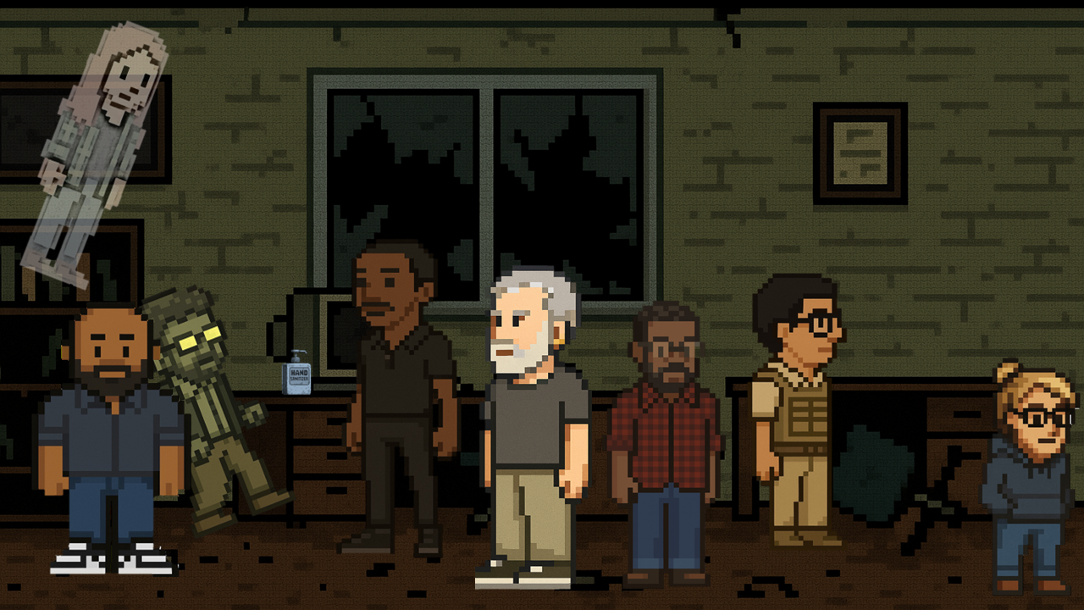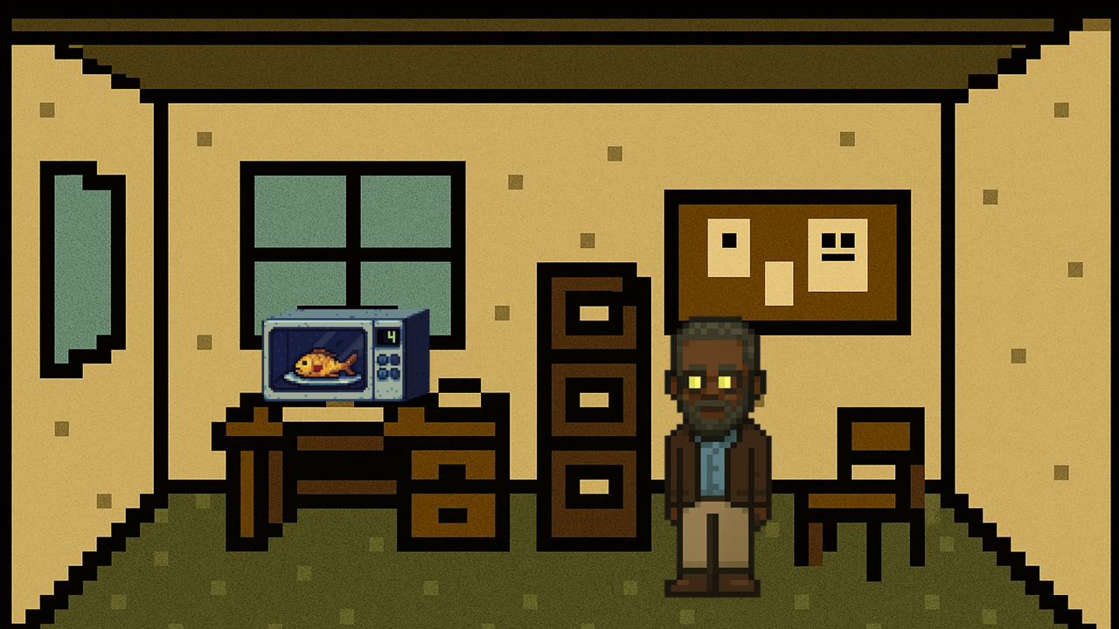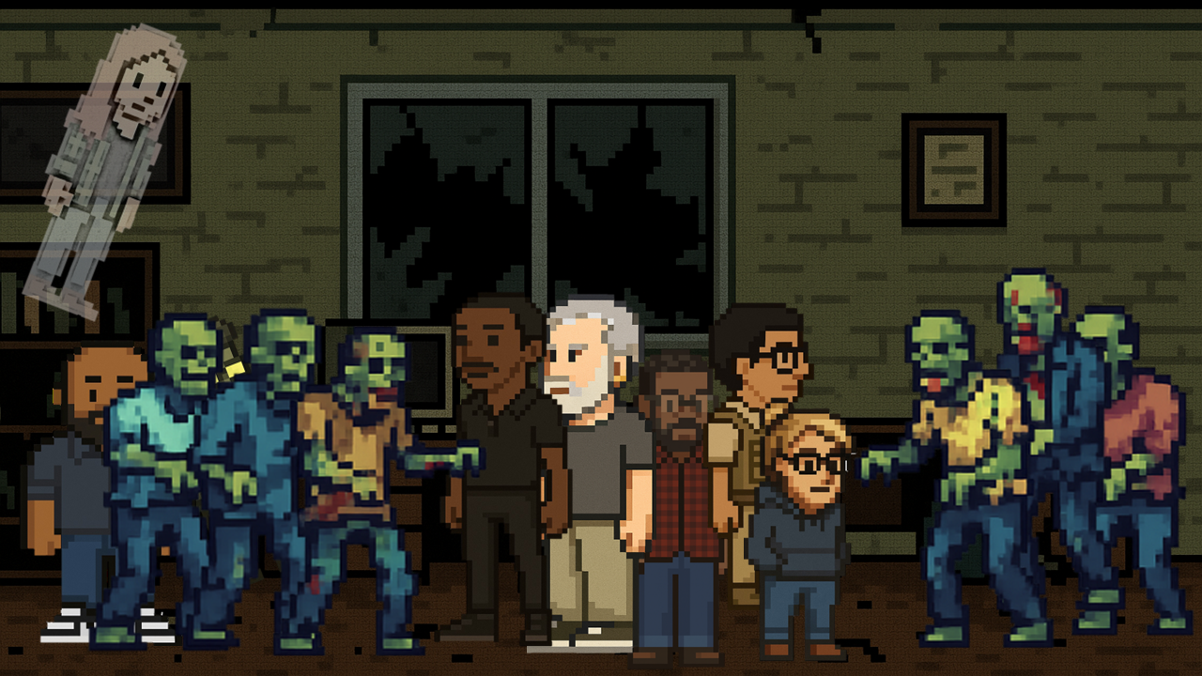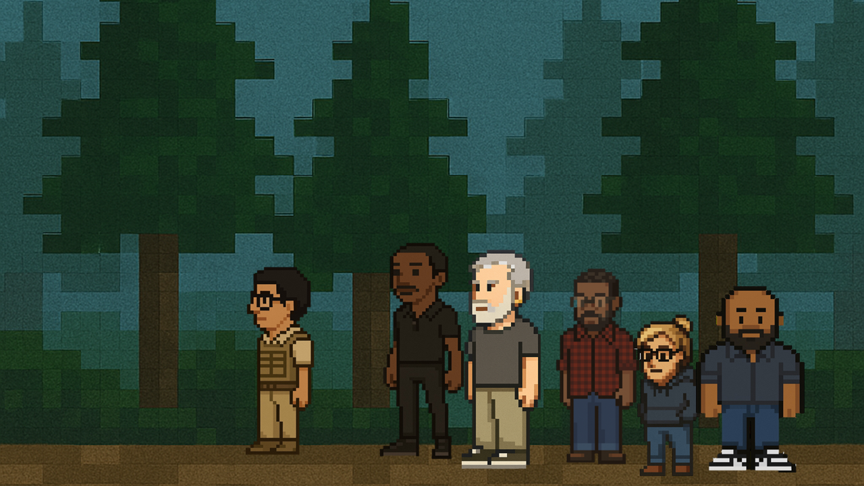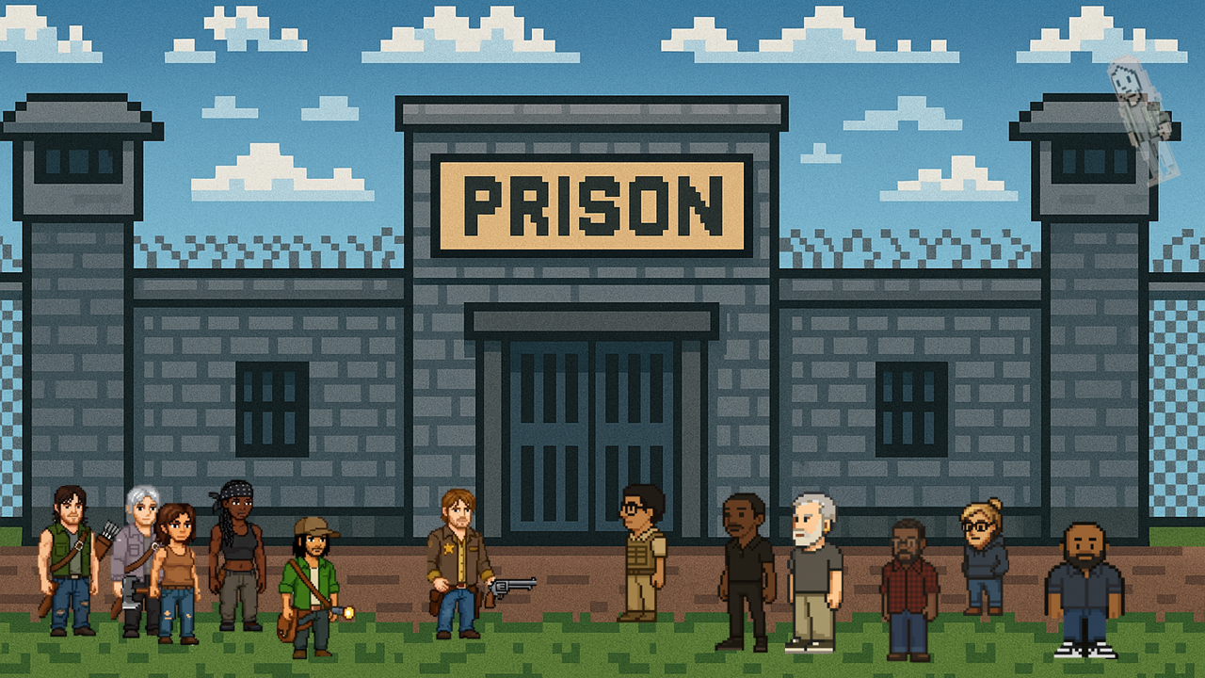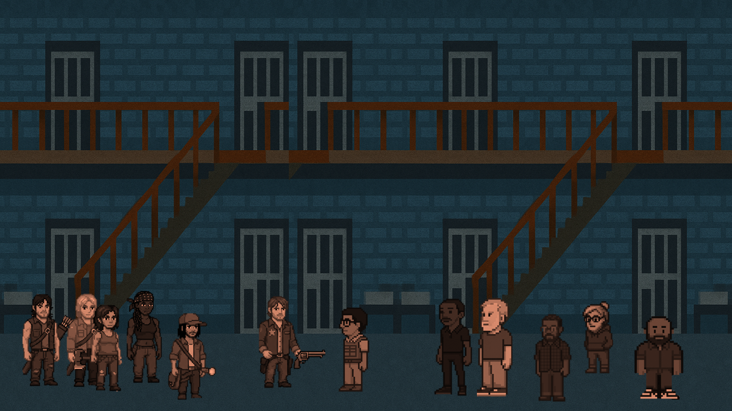.

# Episode 2: "Prison Break (Down)"

* **Written by:** Jordan Peele & Taika Waititi
* **Directed by:** Jordan Peele

**Characters:** (All Previously Defined, including Jason)

## Opening Scenes:

* The Governor's caravan approaches the prison, dust billowing behind them. The scene is intercut with flashbacks to Rob C.'s retirement.
* *Flashback 1:* Rob C. cleaning his desk, looking pensive. Jason (printer guy) walks by. \**Jason:* ** (Warmly) "Congrats, Rob! Gonna miss you bringing in those fish from your weekend adventures. Who will I practice my salsa with now?" \**Rob C.:* (Forced smile) "Thanks, Jason. I'll be sure to send you a postcard. "*Flashback 2:* Jean is in her office typing a resignation letter while on the side she is playing a lottery game.
* **The "Durchfallen" Mirror:** As the Governor's caravan arrives, the screen splits subtly, creating a "Durchfallen" effect. On one side, we see the Governor, charismatic but with a dark glint in his eyes. On the other, we see Jamaal, also charismatic, observing the Governor with a similar glint.
* Rick and the Governor meet outside the prison gates; their faces etched with distrust. John, Ed, and Jamaal stand slightly behind Rick, while Carol and Daryl flank him on the other side. *Rick: "We have a home and are building it, but I cannot and should not stand in the way of others. \**Governor:* "A home is what you make it! And this prison seems well built, well equipped. \**Rick:* "It is not our way to stop others" *Governor: “Those that stop you are going to be the first to fall, and that is why, this prison is mine."

## Act One: "The Phantom Durchfallen"

1. **The Inspection**
   * The Governor and a small group of his men are allowed inside the prison (by Rick to show they have nothing to hide). As they look around:
     + **Dave:** (Whispering to Mac) "I'm detecting heightened adrenaline levels... increased heart rates... they're concealing something... possibly weapons... possibly ill intentions..."
2. **Ed and the Herd:** *Jammal, John, and Ed are scouting while Rick speaks with the Governor.* Meanwhile, Ed tries to make a joke, everyone around just stares silently into him.
3. **Rick and the Governor**

*Rick is now at odds because the Governor is trying to take everything away and is not being transparent. Rick is now considering what he must do to protect the crew.*

*It is noted that on the other side of this action with the Governor and the team being close to one another, is Jamaal. He has gone off and is whispering to his people. He turns to Johnand states "This is what needs to happen if we will ever get what we want. But I need your help."*

*End Act One.*

The important factor to note is to show that tension is coming to light and everyone has sides!

## Act Two: "A New Prison of Hope"

(Focusing on Dave's strategic genius, introducing Jason, and showcasing Ian's growing powers with Carl lurking.)

Scene opens with what the Governor said “After seeing the “power” that I bring I hope we can work together in the future!”

* **Dave** walks along.
  + *“This is the only way that this works but they don’t see it”
  + *Maggie and Glen approach. “You know what I think a lot of the time, that maybe what we need is a new start. The world has gone crazy all we have is each other.”
  + *David then cuts into an old memory and what he would say if he could relive a moment from the past “The best way to connect with people is to know everything about them” The words seem ominous but are a great example of the "Durchfallen" to create contrast. The film reel shows a variety of different movies that have previously been discussed like the "Edge of Tomorrow"* and *‘The Spiderman Verse"*
  + *John may be thinking wait he thought David hadn’t seen them, and he is right. But there is just something he gets out of that, that someone may also get, in a conversation.
  + *“The best way to connect with people is to connect with what you may connect”*
* *As they look at the parameters of the prison the dance begins!*
  + *Enter Jason, a man who is there to make sure we get the most out of our lease. He yells out ***“Is anyone getting the most out of this lease? Why is it so darn hard!”***
  + *David quickly takes a look and says to himself “What a specimen.”
  + He doesn’t say anything to David because as he has told John before if the situation is not as it seems, he will not risk his position in the prison.
  + *Jason says: “The name is Jason, semiprofessional Latin dancer but the printer guy is how most of you would connect!” He then asks if they have thought to use bioinspired concrete for the prison walls as well.

*"It is not a new discovery," but that is what is needed to make sure that his spot is stable.

* *Ian slowly approaches a remote area of the prison and started talking to himself, not seeing Karl lurking in the corner.
  + *"What does he have? What makes “that thing” move? It’s like it remembers what it was but forgot everything along the way."*
  + *The zombie gets up and tries to bite him. Ian stops the zombie in the middle of the attack but is not able to fully control it.*

## Act Three: "Rise of the Durchfallen"

Focusing on intensifying internal conflict, Mac's questionable decisions, Ed's jokes, social commentary, and that all-important Rickism

*Opens into scenes where everything is coming down.* Mac and Carol are talking together, having what seems to be a normal conversation with no real reason to feel the need to get up and leave. \**Mac:* “If there ever gets a point when they hurt you, let me know and they will have a big thing that comes to them! I swear, *I promise I will fix it.” But what is left unsaid is what could turn her down the wrong path. To make someone’s life that much easier so what they did in the past will be nothing what is going on, and what has never been. *Mac leaves with purpose and is going to do everything that she can.*

Ed tells Daryl *“I got out of jury duty this week, what an experience I want to go to a court case and see what goes on at least once” \**Daryl- “what are you even talking about?” Glenn jumps in “What’s the deal man? You are killing my vibes!” **I feel nothing I can't fix this** He makes comments like those.

*Flashback to John's office in which it is just him working and it is empty. The phone rings and John picks up a call from HR stating that Rob C. has retired. The background makes everything seem as if something horrible is going on and John slowly slides down the wall.*

*John is at the bottom of the prison. John looks with what seems to be the saddest eyes in history and then says to himself:*

*"If everyone is dead what does it matter?"* In which someone responds, it’s Rick, in a serious tone *“We will not follow that path here!”*

*“After it has come into fruition, then it happens, it is as a good person but even so it will be so much trouble for even the nicest and most giving of you.”* And after saying the words The Governor appears

Everything starts coming down it feels like something horrible may happen again. After John and the team have done a solid effort there has been a new solution that has changed the hearts and minds of everyone there and *there are people to help* with those. So it is all working, as a result of the amazing crew around there. *But what does that mean for the plan, what will they do and how will all this change that is it makes it worth more or is it something that they needed.* The Governor's voice pierces the chaos, “It is over! "

The sound is loud the group is scattered as all has gone dark, with one line that keeps going the wind: “Help!”